- Spirit Days are every Friday
- Must be a ZHS shirt or a solid Columbia blue or red shirt
- Must be worn with uniform pants and belt
- IDs must be visible at all times
- No sagging pants
- No shorts, skirts, dresses, tights, leggings, or jeggings
- No hoods
- No flip-flops, slippers, crocs, foam runners, or beach/athletic sandals
- No inappropriate language, signs, symbols, or anything advertising alcohol, drugs, or violence
- For PTO jeans/joggers days: No rips, holes, or fake holes

GO BRONCOS!!!

PTO Jeans/Joggers Days:
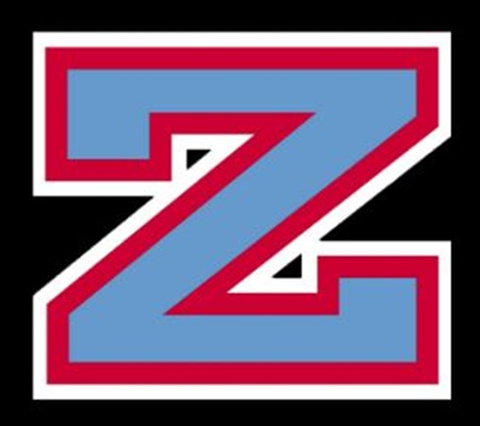
2nd Friday of each month
September 12
October 10
November 7
December 12
January 9
February 6
March 13
April 17
No August or May PTO Jeans/Joggers Day

